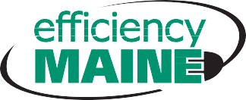

I certify that all statements made in this application are correct to the best of my knowledge, and will abide by the standard Efficiency Maine Program Rules or applicable Incentive Agreement and the Terms and Conditions therein.

5/09/2016

q

q

q

q

q

q

q

q

q

q

**Commercial & Industrial Custom Program**

**Thermal Projects**

Company Name:

Office

Education

Public

Assembly

Retail

Manufacturing

Health

Lodging

Warehouse

Other *(explain)*

Street:

Town:

Expected Completion Date:

Signature: Name (print): Date:

efficiencymaine.com

page 1 of 1

**CUSTOMER ACKNOWLEDGEMENT**

**PROJECT TEAMS**

Team (if selected):

Contact:

Firm:

Phone:

Architect:

Mechanical Engineer:

Electrical Engineer:

General Contractor:

**PROJECT LOCATION**

Mailing Address:

City:

State:

Zip Code:

Contact Name:

Office Phone:

Cell Phone:

Email Address:

Federal Tax ID:

Fax:

Incentive Request:

Expected CO2 Savings:

**PROJECT TYPE**

**PROGRAM PARTICIPANT INFORMATION**